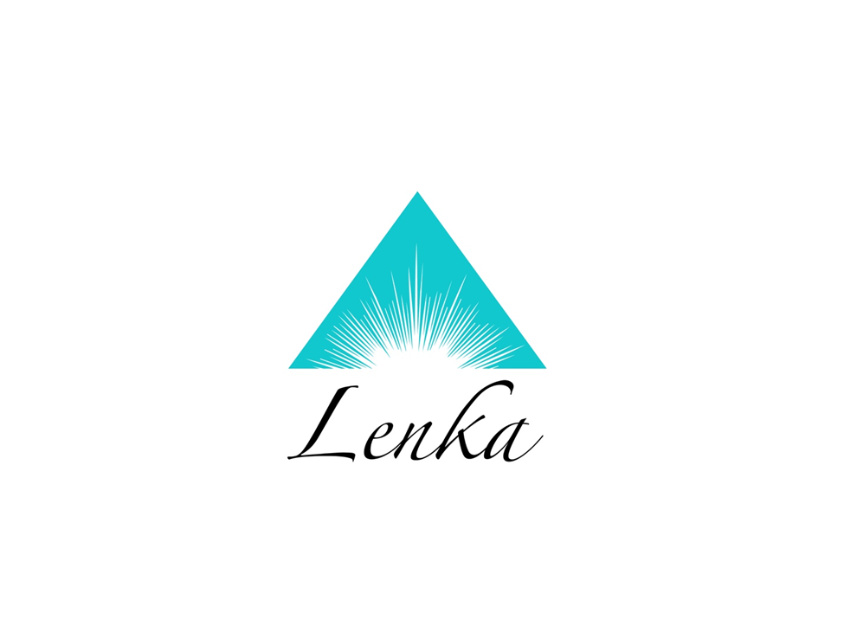

COACHING MASTERY PROGRAM
Reprogramming your mind to raise your consciousness

By: Lenka Spiska
“How to Tap Into Your Energy Field to Promote Wellness”

Are you ready to become the conscious creator of your life and your circumstances? Are you ready to find your true purpose in life and let it guide you to genuine fulfillment?

In just 6 weeks of small-group coaching with master teacher, Lenka Spiska, you will discover how to remove blockages, limitations, and barriers to your authentic self. You will discover how to tap into your inner power on demand, improving your life, health, finances, relationships, and career. You will learn about the innate power we all possess to heal both ourselves and others.

In Power Up, you’ll gain in-depth insight into:
Bioenergetics – learn how to decipher the world of nutrition, interpret overwhelming health advice, live an organic lifestyle on a budget, and maintain a healthy body for life

Energy Medicine – view your life through the lens of the quantum field where everything is energy, vibration, and frequency; uncover your innate potential for healing and creating a life you love through accessing the energy that surrounds you

Meditation – explore this powerful tool for self-mastery; clarify your understanding of what meditation is, how it works, and which type works best for you

Psychoneuroimmunology – examine how your thoughts and emotions affect your overall well-being

Intuition – discover and reawaken your innate intuition; discern true guidance from ego guidance, and learn to trust your gut

Consciousness – learn how your vibration and level of consciousness directly affect your capacity for joy, love, health, and well-being; discover how to understand and utilize the map of consciousness

When you receive and absorb these enlightening concepts, your will find yourself propelled on a journey attracting abundance, love, and health.

But that’s not all.

With your registration, you are also entitled to a FREE half-hour, one-on-one phone consultation with Lenka, addressing how to best apply these concepts in your life, personally. And for the duration of the course, you’ll receive email support from Lenka, too.

Be ready to experience profound, lasting transformation, an enhanced quality of life, and the power to create your own inner peace and happiness.

Please contact us to confirm that we have space for you in this class; class is limited, so reserve your spot today, sign up at lenkaspiska.com.

6 weeks course
Time: 6:30 - 8:00 pm

Early-Bird Pricing (by October 15th): $395
After January 1st: $445

lenkaspiska.com
Connect with me on Facebook:
Lenka Spiska: Empowered Health

