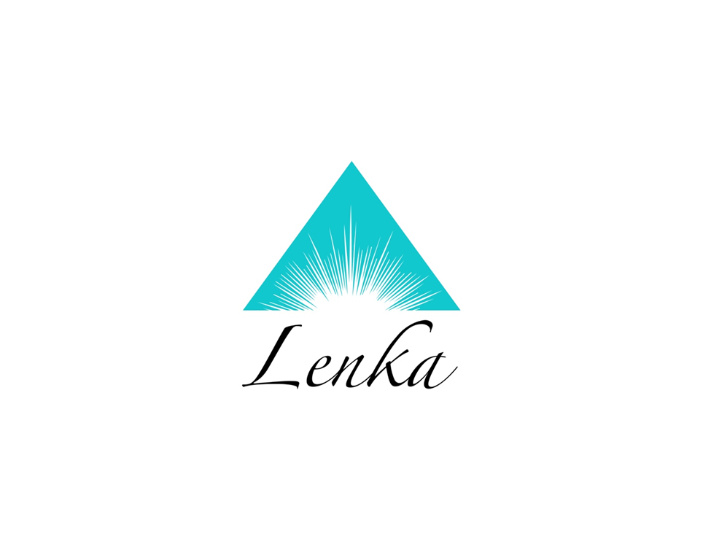

Reiki class Level 2 Introduction to Medical Intuition
Second level Reiki offers an opportunity to expand the skills acquired in Reiki level 1 to new heights. Healing is moved up a notch because the chakras of the hands in level 1 Reiki were only partially open and now the energy can be fully accessed via the level two attunement. Attunements in Reiki Level 2 opens the initiated to a higher level of consciousness by expanding the crown chakra even more, thus creating a clearer connection to Universal Intelligence. This attunement will increase and amplify the intuition already achieved in Reiki Level 1. New symbols are presented which aid in distant healing as well as stimulating new perceptions in the mental and emotional arena.
Reiki Level 2 outline;
-Review of Reiki level 1
-Completion of opening the chakras in the palms and expansion of the crown chakra
-Ability to fully connect with the chakra system of recipient
-Attunement to new symbols to access hidden mental and emotional issues
-Understand how to heal at distance, into the past or future
-Receive a pendulum and instructions for its use
-Learn how to lovingly release unhealthy connections to others via ”cords”
-Animal treatments and communication with them
-Practice the “Five Tibetan Rites” to keep chakras spinning while you stay and feel younger
-Increased integration of “Higher Self” consciousness
-Activation of another 21day-chakra cleansing cycle

Please contact me to confirm that we have space for you preferred class date, space is limited, so sign up today!
www.lenka.org

